Algebra 1 Name:______________________

8.3 Preview

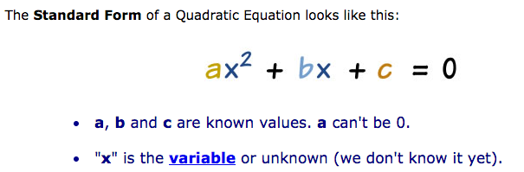

**Examples:**

|  |  |
| --- | --- |
| **Function** | **a, b, and c coefficients** |
| 1. | a = 2, b = -4, c = 7 |
| 2. | a = -4 b = 0 c = 1 |
| 3. | a = 1 b = 3 c = -15 |

**Now you try….**

**Write the equation in standard form. Then, state the a, b, and c coefficients.**

|  |  |  |
| --- | --- | --- |
|  |  |  |
|  |  |  |
|  |  |  |

**Evaluate for given values of *a* and *b*. Leave your answers as reduced fractions.**

|  |  |  |
| --- | --- | --- |
|  |  |  |
|  |  |  |

**Spiral Review.**

|  |  |
| --- | --- |
| 1. **Solve.** | 1. **Solve.** |
| 1. **Write an equation that passes through the given point and is parallel to the equation.** | 1. **Solve the equation** |
| 1. **Evaluate.** | 1. **Simplify.** |