Geometry Name: \_\_\_\_\_\_\_\_\_\_\_\_\_\_\_\_\_\_\_\_\_\_\_\_\_\_\_\_\_

Pre-skills worksheet 1.4-1.6

In Exercises #1–6, find the perimeter and area of the figure.

|  |  |  |
| --- | --- | --- |
| TA: K:\BI-HighSchool\Geometry.01\Ancillaries\Production\Geometry RBC\rbc art\ch 01\HSGeo_rbc_01cr_000.eps,4/9/2014 2:13:24 PM replaced: 7/31/2016 4:55:31 PM1.  P= \_\_\_\_\_\_\_\_\_\_\_\_ A=\_\_\_\_\_\_\_\_\_\_ | 2.  TA: K:\BI-HighSchool\Geometry.01\Ancillaries\Production\Geometry RBC\rbc art\ch 01\HSGeo_rbc_01cr_001.eps,4/9/2014 2:25:50 PM replaced: 7/31/2016 4:55:32 PM  P= \_\_\_\_\_\_\_\_\_\_\_\_ A=\_\_\_\_\_\_\_\_\_\_ | 3.  TA: K:\BI-HighSchool\Geometry.01\Ancillaries\Production\Geometry RBC\rbc art\ch 01\HSGeo_rbc_01cr_002.eps,4/11/2014 2:46:38 PM replaced: 7/31/2016 4:55:33 PM  P= \_\_\_\_\_\_\_\_\_\_\_\_ A=\_\_\_\_\_\_\_\_\_\_ |
| 4.  TA: K:\BI-HighSchool\Geometry.01\Ancillaries\Production\Geometry RBC\rbc art\ch 01\HSGeo_rbc_01cr_004.eps,4/9/2014 2:42:21 PM replaced: 7/31/2016 4:55:34 PM  P= \_\_\_\_\_\_\_\_\_\_\_\_ A=\_\_\_\_\_\_\_\_\_\_ | 5.  TA: K:\BI-HighSchool\Geometry.01\Ancillaries\Production\Geometry RBC\rbc art\ch 01\HSGeo_rbc_01cr_003.eps,4/11/2014 2:46:52 PM replaced: 7/31/2016 4:55:34 PM  P= \_\_\_\_\_\_\_\_\_\_\_\_ A=\_\_\_\_\_\_\_\_\_\_ | 6.  ../../../../Screen%20Shot%202018-06-07%20at%206.05.32%20PM.png  P= \_\_\_\_\_\_\_\_\_\_\_\_ A=\_\_\_\_\_\_\_\_\_\_ |

Solve the equation.

|  |  |  |
| --- | --- | --- |
| 7. | 8. | 9. |

Solve the system of linear equations by substitution or elimination.

|  |  |
| --- | --- |
| 10. $\begin{matrix}y=3x-2 \\ x-y=4\end{matrix}$ | 11. $\begin{matrix}-2x+2y=6 \\ 4x+2y=-5\end{matrix}$ |

Write an equation of a line in slope-intercept form given the slope and the y-intercept. *y = mx + b*

|  |  |  |
| --- | --- | --- |
| 12. Slope = -7  y-intercept = 0 | 13. Slope = $\frac{3}{2}$ y-intercept = -11 | 14. Slope = $-\frac{1}{5}$ y-intercept = 5 |

Write an equation of a line given the slope and a point. *y - y1 = m (x - x1)*. Then, convert into slope-intercept form. *y = mx + b*

|  |  |  |
| --- | --- | --- |
| 15. Slope = -5  Point: ( 1, -1)  Point-slope:  Slope-intercept: | 16. Slope = 2  Point: ( $\frac{3}{2}$, -8 )  Point-slope:  Slope-intercept: | 17. Slope = -1  Point: ( -2, -4)  Point-slope:  Slope-intercept: |
|  |  |  |

18. Find *AC*. 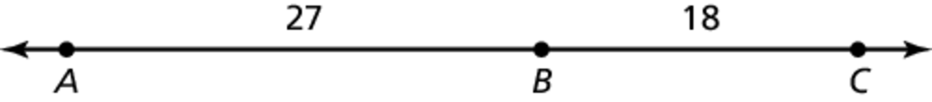 19. Find *DF*.

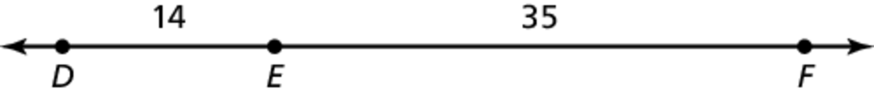

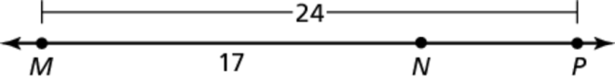20. Find *NP*. 21. Point *M* is the midpoint of  Find NP.

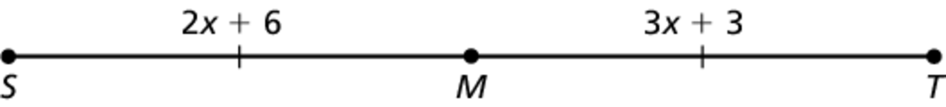

22. Given that  is a right angle, find  and .

**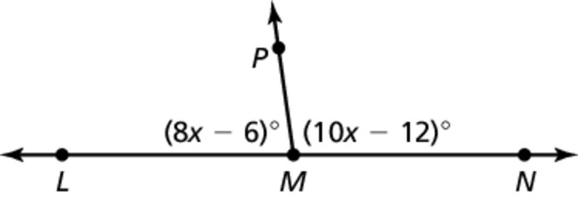**23. Given that  is a straight angle, find  and 

**